John Michael Go
Career Entry Level Java Programming
Date: Jan. 11, 2013

DAY 1

Program Name: Hello World

Objective: Hello World Program and sum of two numbers

Algorithm:

- Program will display the Hello World message and the sum of 2 and 3.

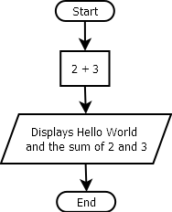
Flowchart:

Pseudocode:

public class HelloWorld{
public static void main (String[]args){
System.out.println ("");
System.out.println("Hello World, the sum of 2 and 3 = " + (2+3));
System.out.println ("");
System.out.println("Hello World");
System.out.println ("");
System.out.println ("");
System.out.println ("");

}

}

Screenshot:

